# UNIT 2

**Computer Architecture**



Picture 2.1

**Learning Outcomes**: By the end of the lesson, the students are expected to be able to use appropriate English to:

* identify and describe kinds of computer
* read a computer advertisement
* identify parts of computer
* describe functions of parts of computer
* identify comparatives and superlatives
* identify phrases used for presentation
* perform a presentation using phrases explained
* compare and contrast computers and any other devices using comparative and superlatives

# Reading a computer advertisement

**Exercise 1:** You are going to listen to an extract from an ICT class about **five** types of computer.

As you listen, identify the pictures (a-e) with words from the box.

Mainframe

Tablet PC

Desktop PC

PDA

Laptop

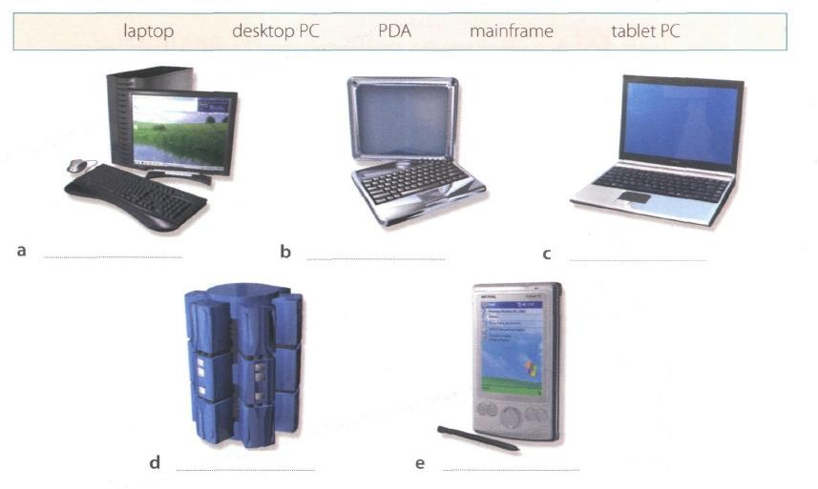

Picture 2.2

**Exercise 2**: Listen again and decide whether these sentences are true or false. Correct the false ones.

* + 1. A mainframe computer is less powerful than a PC. (F)
    2. A mainframe is used by large organizations that need to process enormous amounts of data. (T)
    3. The most suitable computers for home use are desktop PC. (T)
    4. A laptop is not portable. (F)
    5. Laptops are not as powerful as desktop PCs. (T)
    6. Using a stylus, you can write directly onto the screen of a tablet PC. (T)
    7. A Personal Digital Assistant is small enough to fit into the palm of your hand. (T)
    8. A PDA does not allow you to surf the Web. (F)

**Exercise 3**: Match these names to the different types of computer.

Tablet

Laptop

Supercomputer / Mainframe

Minicomputer

Microcomputer

PC

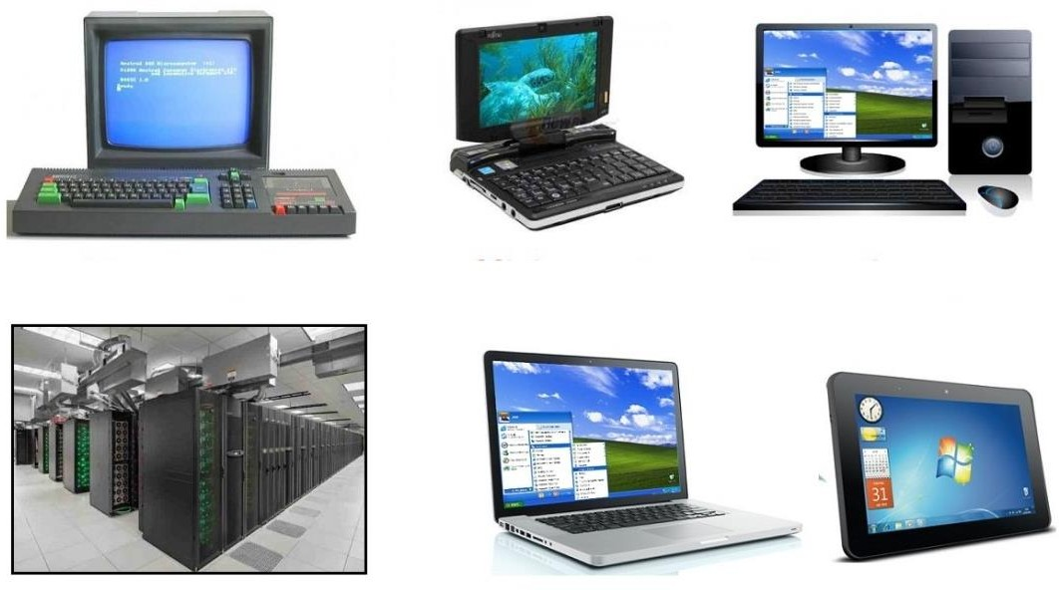

Picture 2.3

|  |  |  |
| --- | --- | --- |
| 1. minicomputer | 3. tablet | 5. PC |
| 2. laptop | 4. microcomputer | 6. supercomputer/mainframe |

**Exercise 4**: Listen to Part 1 of the conversation between a shop assistant and a customer. Tick

(√) the correct answers to the questions below.

1. The customer wants a computer for......
   * writing □ internet □ games
   * graphics □ video
2. A multimedia computer provides......
   * sound □ telephone
   * graphics □ video
   * games

**Exercise 5:** Listen to Part 2 of the conversation. In column A, tick hardware items named. In

column B, tick the items the assistant recommends.

|  |  |  |  |  |  |
| --- | --- | --- | --- | --- | --- |
| **A** | **B** | **Device** | **A** | **B** | **Device** |
| □ | □ | multimedia computer | □ | □ | handheld |
| □ | □ | multimedia notebook | □ | □ | printer |
| □ | □ | subnotebook | □ | □ | monitor |
| □ | □ | laptop | □ | □ | Modem |

**Exercise 6**: Study the text entitled ”How to Read a Computer Ad” and then answer the following

questions.

1. What is the memory size of PC?

* 512 SSD & 2 TB Serial ATA hard drive (7.200 r.p.m)
* **16GB dual channel DDR4 SDRAM**

1. What storage devices are supplied?

* Hard disk
* **512 SSD & 2 TB Serial ATA hard drive (7.200 r.p.m)**

1. What size is the display screen?

* Fourty-two inch

1. How fast is the processor?

* The processor operates at a clock speed of threepoint six gigahertz and has a front-side bus that operates at a speed of eight hundred megahertz.

1. What is the capacity of the hard drive?

* Two terabytes

1. Which operating system does it use?

* Microsoft Windows 10 Professional

1. What multimedia features does the computer have?

* 8 GB GDDR6 NVIDIA PCI-Express video graphic card

**HOW TO READ A COMPUTER AD.**

|  |  |
| --- | --- |
| 1. Intel Core i7-9700K 9th Generation (Coffee lake). Base Clock: 3.6 GHz, Bus Speed: 800 MHz 2. Mini-tower chassis 3. 16 GB dual channel DDR4 SDRAM 4. 512 SSD & 2 TB Serial ATA hard drive (7200 r.p.m) 5. 8 GB GDDR6 NVIDIA PCI-Express video graphic card 6. Integrated Dolby Atmos Stereo audio 7. Corsair K95 RGB Platinum Keyboard 8. 42” TFT flat panel 4K (3840 x 2160) monitor 9. Microsoft Windows 10 Professional | TowerPC  Picture 2.4 |

|  |  |  |
| --- | --- | --- |
| 1. The main processing chip called a ‘core i7’ that was designed and manufactured by the intel Corporation. It operates at a clock speed of three- point six gigahertz and has a front-side bus that operates at a speed of eight hundred megahertz. 2. A small, tall and narrow style of case containing the computer system. 3. Synchronous dynamic random-access memory with a capacity of sixteen gigabyte. It is a high bandwidth, double data rate memory. | 1. A Solid-state drive with a 512 gigabytes storage and a hard drive with a capacity of two terabytes that uses a type of connection interface known as Serial ATA. It has a serial data connection rather than the original parallel connection. It rotates at a speed of seven thousand, two hundred revolutions per minute. 2. Electronics for driving the graphics output that has a memory capacity of eight gigabytes and uses a type of connection interface known as PCI-Express. | 1. Electronics for controlling the sound output that is built into the main electronics of the computer. 2. The K95 Platinum is a big keyboard. Dedicated media controls and a USB pass-through, a metal volume wheel, RGB lighting. It even comes with an extra set of textured keycaps for the WASD keys. 3. A forty-two inch, flat display screen made from thin film transistors with a resolution of 3840 by 2160. 4. The operating system that is used to control the   system. |

*Oxford English for Information Technology (2011: 11)*

# Describing functions of computer

We can describe the function of an item in a number of ways. Study these examples.

|  |  |
| --- | --- |
| **Using the present simple**   1. ROM *holds* instruction which are needed to start up the computer.   ***Used to-*infinitive, *Used for + -ing***  **form**   1. ROM is *used* to *hold* instructions which are needed to start up the computer. | 1. ROM is *used for holding* instructions which are needed to start up the computer.   **Emphasizing the function**   1. *The function of ROM is* to hold instruction which are needed to start up the computer. |

**Exercise 7**: Match each item with its functions. Then describe the functions in three ways as the

examples on the table above.

|  |  |
| --- | --- |
| **Items** | **Functions** |
| 1. RAM (G) 2. Processor (J) 3. Mouse (A) 4. Clock (I) 5. flash memory key (E) 6. monitor (C) 7. keyboard (B) 8. cache (F) **(H)** 9. DVD-ROM drive (D) 10. ROM (H) **(F)** | 1. controls the cursor 2. inputs data through keys like a typewriter 3. displays the output from a computer on a screen 4. reads DVD-ROMs 5. reads and writes to electronic chips on a card 6. holds instructions which are needed to start up the computer 7. holds data read or written to it by the processor 8. provides extremely fast access for sections of a program and its data 9. controls the timing of signals in the computer 10. controls all the operations in a   computer |

**Exercise 8**: With your partner, describe the functions of these items using the forms you have

learned before.

* + 1. Scanner : To converts the image on the document into digital
    2. Printer : To presents text or images to flat media such as paper
    3. CPU : To process input, store data, and output results
    4. SSD : To loads files quicker and saved faster
    5. Hard Disk Drive : To stores operating systems, software programs and other files using magnetic disks
    6. Ports : To acts as a point of attachment, where the cable from the peripheral can be plugged in and allows data to flow from and to the device
    7. Mainframe computer : To bulks data process for tasks such as censuses, industry and consumer statistics, enterprise resource planning, and large-scale transaction processing.
    8. Barcodes : To provides information to a computer system, which is used to track inventory, pricing, and other data
    9. Swipe cards : A card that contains information that can be read or transferred by passing the card through a special machine
    10. Main memory : To holds instructions and data when a program is executing

# Comparing and contrasting computer

**Exercise 9:** Study these details of different types of computer. Find answers to the questions.

Which computer is?

* + 1. The most common?
* PC
  + 1. Small enough for a pocket?
* Subnotebook
  + 1. The most common portable?
* Notebook
  + 1. Used by many people at the same time?
* Mainframe
  + 1. Used like mainframes?
* Minicomputer
  + 1. Also called a handheld computer?
* Palmtop
  + 1. The most powerful?
* Mainframe
  + 1. Not suitable for a lot typing?
* Handheld

|  |  |
| --- | --- |
| **Types of Computer** | **Notes** |
| **Mainframes** | Large, powerful, expensive.  Multi-user systems – used by many people at the same time.  Used for processing very large amounts of data. The most powerful mainframes are called  *supercomputers.* |
| **Minicomputers** | Used like mainframes.  Not as big, powerful, or expensive as mainframes. Less common now because microcomputers have improved. |
| **Microcomputers or Personal**  **computers (PCs)** | The most common type of computer.  Smaller, cheaper, and less powerful than mainframes and minicomputers. |

|  |  |
| --- | --- |
| **Types of Portable** | **Notes** |
| **Laptop** | About the size of small typewriter.  Less common now because smaller and lighter portables are available. |
| **Notebook** | About the size of a piece of writing paper.  The most common type of portable. |
| **Subnotebook** | Not quite as big as notebooks. Can fit into a jacket pocket. |
| **Handheld or Palmtop** | Small enough to fit into the palm of one hand. Not easy to type with because of their size.  Specialized handheld computer known as PDAs are used as  personal organizers. |

**Exercise 10:** Study this comparison of three types of computer.

|  |  |  |  |
| --- | --- | --- | --- |
|  | **Mainframes** | **Minicomputers** | **Microcomputers** |
| **Size** | **+++** | **++** | **+** |
| **Power** | **+++** | **++** | **+** |
| **Cost** | **+++** | **++** | **+** |

We compare things using adjectives in two ways.

1. We can compare one type of computer with another.

*Minicomputers are* ***bigger than*** *microcomputers. Mainframes are* ***more expensive than*** *microcomputers.* For negative comparisons, we can say:

*Microcomputers are* ***not as big as*** *minicomputers. Microcomputers are* ***not as powerful as*** *mainframes.*

1. We can compare mainframes to all other types of computer.

*Mainframes are* ***the biggest*** *computers. Mainframes are* ***the most powerful*** *computers. Mainframes are* ***the most expensive*** *computers.*

With short adjectives (big*, small, fast*), we add *–er* and *–est* (*faster, fastest*). With longer adjectives (*powerful, expensive*), we use *more/less* and the *most/ the least* before the adjectives (*more powerful, the most powerful)*.

Remember some exceptions:

*good – better – the best bad – worse – the worst*

**Exercise 11:** Choose the correct adjectives. Then fill in the gaps with the correct form of the

adjectives.

|  |  |
| --- | --- |
| ***light/heavy***  ***large/small***  ***common/good***  ***powerful/expensive***  ***fast/cheap***  ***powerful/expensive*** | Laptops are **1 lighter** than desktop computers, but  **2heavier** than notebooks.  The mainframes is the **3largest** type of computer. A minicomputer is **4smaller** than a microcomputer.  Personal computer are **5more common** than mainframes but mainframes are **6better** than personal computers at processing very large amounts of data.  Minicomputers are **7 less not powerful** than mainframes but they are also **8  less not expensive**  New computers are **9 fastest faster** and sometimes  **10cheaper** than older machines.  Laptops are often **11more powerful** than PCs but they are not as **12** **expensive as PCs** |

**Exercise 12**: Put the words in brackets into the correct form.

There are different types of computer. The (*large*) **1larger largest** and (powerful)

**2the most powerful** are mainframe computers. Minicomputers are (small)

**3smaller** than mainframes but are still very powerful. Microcomputers are small enough to sit on a desk. They are the (common) **4most common** type of computer. They are usually (powerful) **5more powerful** than microcomputers.

Portable computers are (small) **6smaller** than desktops. The (large)

**7larger largest** portable is a laptop. (Small) **8The smallest smaller** portables, about the size of a piece of writing paper, are called notebook computers. Subnotebooks are (small)

**9smaller** than notebooks. You can hold the (small) **10 The smallest**

computers in one hand. They are called handheld computers or palmtop computers.

**Exercise 13**: In pairs, discuss who or what you think is:

1. The most difficult game you’ve ever played.

* I have the most difficulty playing Mobile Legends games, because there are so many heroes with different skills, I can't play all of these heroes

1. The most exciting film you’ve ever seen.

* Kimi no na wa, it seems like it was the film that made me the most excited in my entire life, unfortunately I couldn't feel that again a second time

1. The funniest program on TV.

* Of course 2 Days 1 Night !!! That is a Korean variety show which is very funny, I always laugh until my stomach hurts when I watch it

1. The most dangerous computer virus.

* Honestly I don’t know what viruses are on the computer, but after I found out there is a virus called trojan, it seems it is a very dangerous virus

1. The best blogger or webmaster on the web

* Santrikoding, the website contains programming tutorials, I once studied Laravel there, and the instructions are very easy

1. The most popular web browser.

* Maybe, chatGPT, because that AI website makes it very easy for today's youth to do their assignments

**Exercise 14**: Preparation is essential for an effective presentation. Here are some phrases that

can help you delivering a better presentation.

# Useful Phrases for Presentation

When giving a presentation, certain keywords are used to signpost the different stages. It’s a good idea to memories them and practice them so that they come to your mind easily during a presentation.

|  |  |
| --- | --- |
| **Useful Phrases for Presentation** | |
| **Starting the presentation** | **Explaining the purpose** |
| * Good morning/good afternoon ladies and gentlemen. * The subject of my presentation today is … * What I’m going to talk about today is … | * The purpose of this presentation is … * My objective is to … * My main aim today is to … |
| **Stating the main points** | **Introducing the first point** |
| * The main points I will be talking about   today are firstly …, secondly …., next …., finally, we’re going to look at… | * Let’s start/begin with … * I’d like to start by …. |
| **Showing visuals** | **Moving on to the next point** |
| * I’d like to illustrate this by showing you … | * Now let’s move on to … |
| **Referring to an earlier point** | **Summarizing** |
| * Let me go back to what I said earlier about   … | * I’d like to recap the main points of my presentation. First I covered …, then we   talked about … and finally we looked at …   * I’d now like to sum up the main points, which were … |

|  |  |
| --- | --- |
| **Conclusion Inviting** | **Questions** |
| * I’m going to conclude by … saying that / inviting you to / quoting … * In conclusion, let me leave you with this   thought / invite you to … | * Finally, I’ll be happy to answer your   questions.   * Now I’d like to invite any questions you   might have.   * Do you have any questions? |

**Exercise 15**: Now put the following phrases in the correct groups. Add some more phrases that

you know.

* In conclusion, let me leave you with this thought / invite you to …
* Good morning/good afternoon ladies and gentlemen.
* The main points I will be talking about today are firstly …, secondly …., next …., finally, we’re going to look at…
* I’m going to conclude by … saying that / inviting you to / quoting …
* Now let’s move on to …
* My objective is to …
* Finally, I’ll be happy to answer your questions.
* Now I’d like to invite any questions you might have.
* What I’m going to talk about today is …
* The subject of my presentation today is …
* I’d like to illustrate this by showing you …
* I’d like to recap the main points of my presentation. First I covered …, then we talked about

… and finally we looked at …

|  |  |
| --- | --- |
| Useful Phrases for Presentation | |
| **Starting the presentation** | **Explaining the purpose** |
| * Good morning/good afternoon ladies and gentlemen. * What I’m going to talk about today is … * The subject of my presentation today is … * **Hello guys, how is everybody doing here?** * **The title of my presentation today is…** * **Thanks guys for the opportunity, today I will present** | * My objective is to … * **The purpose of my standing here is…** * **There are several objectives of this presentation, that is…** * **This presentation aims to…** |
| **Stating the main points** | **Introducing the first point** |
| * The main points I will be talking about today are firstly …, secondly …., next …., finally, we’re going to look at… * **Here are some points that I will present…** * **First, I will mention what points are in my presentation, first is…** | * **Firstly…** * **Lets go to the first point…** * **The first point is…** |
| **Showing visuals** | **Moving on to the next point** |
| * I’d like to illustrate this by showing you … * **Let me show you…** * **Give your attention to…** * **Look at this…** | * Now let’s move on to … * **Next…** * **Let’s move on to the next point** |
| **Referring to an earlier point** | **Summarizing** |
| * **As I explained before…** * **Based on what I explained previously…** * **As I mentioned in point...** | * I’d like to recap the main points of my presentation. First I covered …, then we talked about … and finally we looked at … * **In a nutshell…** * **To put it simply…** * **To wrap things up…** |
| **Conclusion** | **Inviting Questions** |
| * In conclusion, let me leave you with this thought / invite you to … * I’m going to conclude by … saying that / inviting you to / quoting … * **In conclusion…** * **The conclusion of my presentation is…** | * Finally, I’ll be happy to answer your questions. * Now I’d like to invite any questions you might have. * **That's all from me, do you have any questions?** * **Any question?** |

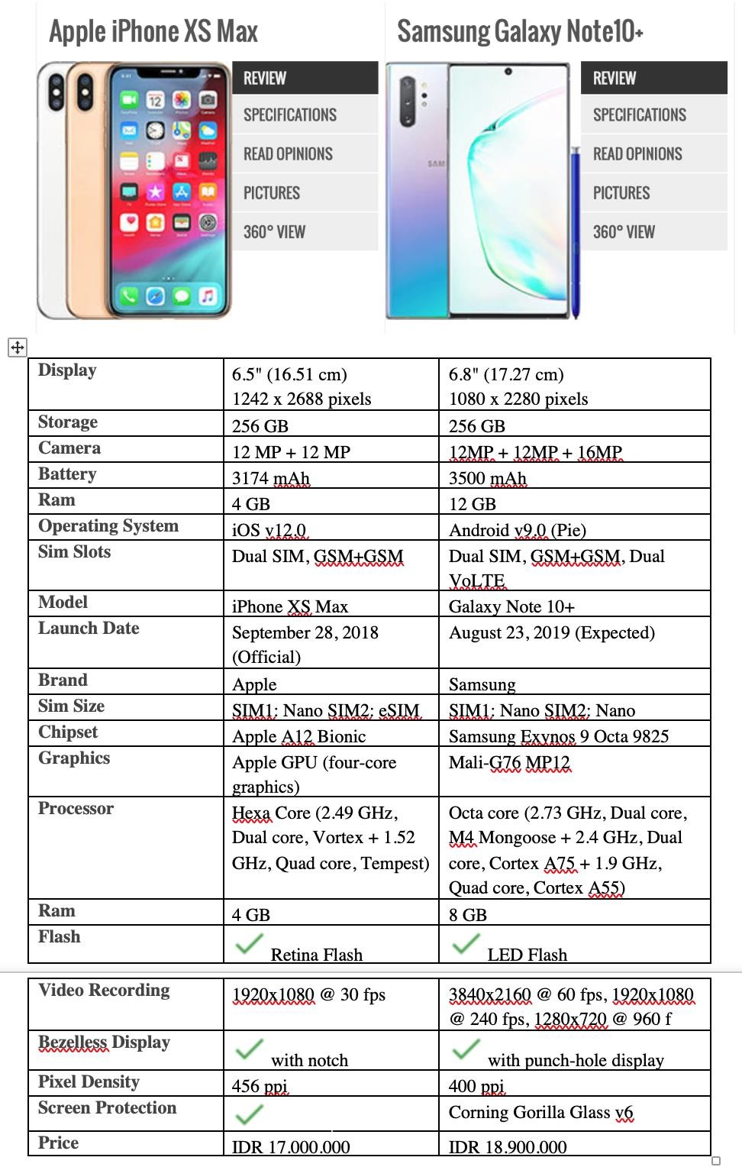

Picture 2.5

**Exercise 16**: In pairs, find two different advertisements of PCs/laptops/any gadgets and write some comparisons (at least 10 sentences) based on their specifications and present it in the class. Use the phrases that you have learned today.

# Look at the example below.

**Example of Writing a Comparison between Two Things**

1. Samsung Galaxy Note 10+’s size is bigger than iPhone XS Max’s.
2. The storage of Samsung Galaxy Note 10+ and iPhone XS Max has the same capacity.
3. The price of Samsung Galaxy Note 10+ is more expensive than iPhone XS Max.

4. …..

5. …..